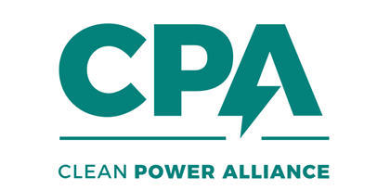
[Date]
[Respondent Address]
Attention:
Subject: Letter of Support
Regarding: [Project Name]

Dear Respondent:
Clean Power Alliance of Southern California (“we” or “CPA”) is pleased to support the proposal submitted by [Company Name], (“you” or “Respondent”) for the [Project Name] (“Project”) (the “Proposal”) in CPA’s Clean Energy Innovation Solicitation: Emerging Technologies and New Business Models. Respondent’s next-generation clean energy resource aligns with CPA’s mission to empower communities with access to cost-competitive electricity and a diverse choice of clean energy options. This letter of support reinforces our shared commitment to reducing greenhouse gas emissions, advancing renewable energy development, and fostering green job growth.
CPA understands from the Proposal that the Project is in early stages of development, and it enthusiastically awaits further information as the Project moves toward full commercial viability. Respondent may, at any time, submit a revised Proposal to CPA with a firm price (or revised firm price) for CPA’s consideration. CPA will re-evaluate the Proposal and assess if CPA is prepared to negotiate a long-term power purchase agreement (“PPA”).
Please note that working toward satisfying the following conditions will help Respondent prepare for entering into a PPA: (a) obtaining site control; (b) environmental review and permitting; (c) applying for Project interconnection to the applicable interconnection provider (e.g. the California Independent System Operator and/or interconnecting utility) and (d) demonstrating technology commercial feasibility. Please let us know if you have any questions in the meantime by emailing us at procurement@cleanpoweralliance.org. We sincerely hope to be able to work with you on this Project in the future.
Very truly yours,
CLEAN POWER ALLIANCE OF SOUTHERN CALIFORNIA
a California Joint Powers Authority

By: ____________________________
Name: __________________________
Title: ___________________________

